
Machine Learning Foundations
Professor. Prashanth L A
Department of Computer Science and Engineering
Indian Institute of Technology, Madras
Diagonalization of a Matrix
Welcome to lecture no 3 in week 4 of machine learning foundations. In this lecture we will start the discussion about similarity and diagonalization of a matrix. In particular, we will define what it means to say our matrix A is diagonalizable and will relate this to the idea of linear independence of eigenvectors of this matrix. So, the question of whether a matrix is diagonalizable is strongly related to how many linearly independent eigenvectors I can get and I get enough to diagonalize this matrix.
And then we will look at a very special case: Imagine you have a n ×n matrix. If I can get a n linearly if all the eigenvalues of this matrix are distinct, then it is diagonalizable because I can get enough eigenvectors. And that is a particular special case, interesting special case that we will see. And in the subsequent lectures we will build up this theory to go to the final claim which is to understand which is the spectral theorem which says that any real symmetric matrix is diagonalizable. We will get there in the steps. That is the final claim that we are heading towards.
(Refer Slide Time: 1:36)
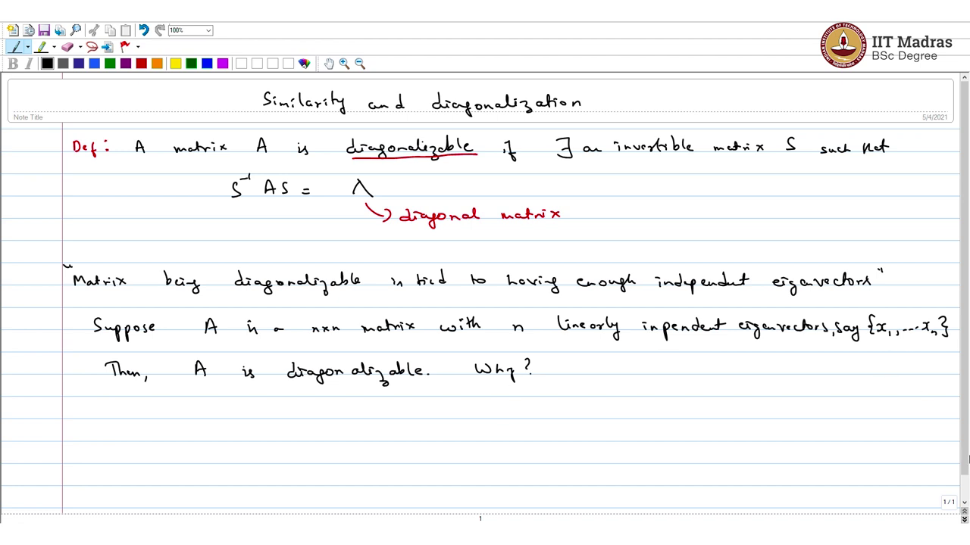
So, welcome everyone to another lecture on linear algebra the module that we are looking at in the previous lecture we looked at eigenvalues and eigenvectors and looked at some motivation using ordinary differential equations. And today we will look at a very important topic associated with eigenvalues and eigenvectors which is similarity and diagonalization of matrices. So, what is a diagonalizable matrix?
So, let us start with the definition, a matrix A is diagonalizable if there exists an invertible matrix S such that if I do S⁻¹AS, then what I get is a diagonal matrix. So, if this condition is satisfied which is like saying that if I can find an invertible matrix such that S⁻¹AS = λ which is a diagonal matrix, then the matrix A is diagonalizable.
So, now let us dig further into this. When is a matrix diagonalizable a matrix is, a matrix being diagonalizable is really tied to having enough independent eigenvector. So, let us understand this. For what do I mean by this statement? Let us make this claim precise. So, suppose A is a n ×n matrix with n linearly independent eigenvectors. Say {x₁…. Xn} this is the set of eigenvector, then A is diagonalizable.
Why? I mean for diagonalizability what do we need to show? We need to manufacture matrixes which will be invertible and S⁻¹ A is a diagonal matrix. So, how do we do that?
(Refer Slide Time: 4:54)
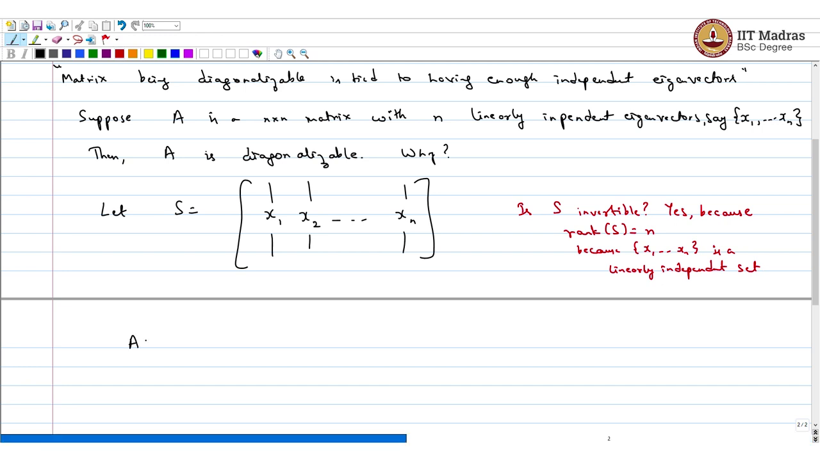
Let us let me show you such a matrix. Let S equals you take all this eigenvector that you have and put them as columns in the matrix and let me call that matrix S. So, the question now is S invertible? So, I would say pause the video and think about this now. what is the rank of S? Rank of S is n because {x_{1…}..., xn} is a linearly independent set. This because so linearly independent set so it has full column rank and its n × n matrix. We are looking at we are looking at vectors in n dimensional Euclidean space. What is AS?
(Refer Slide Time: 6:08)
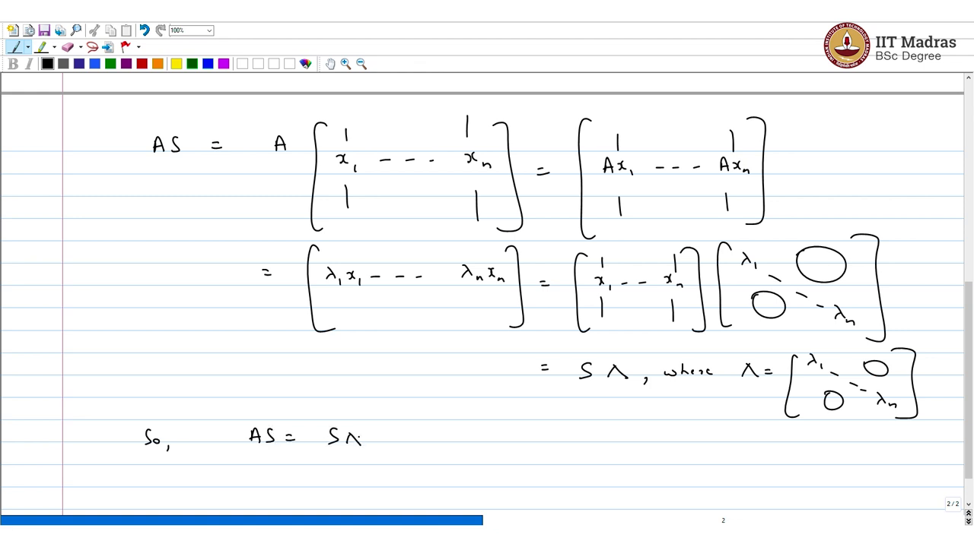
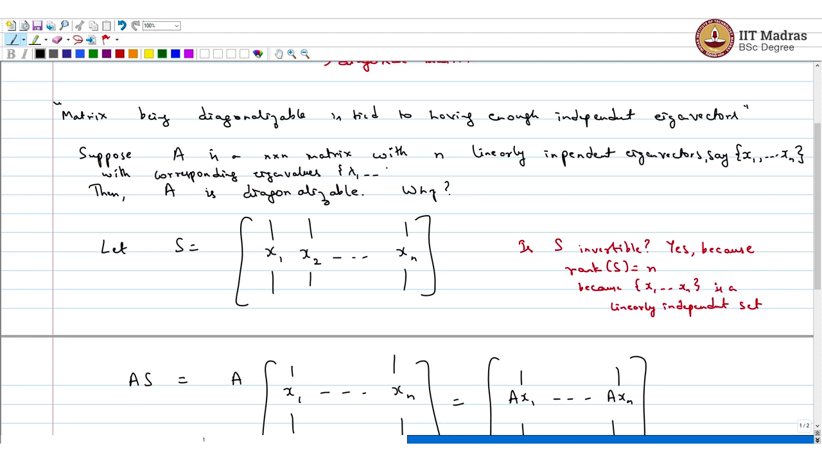
AS is A [x_{1…}, xn] which is nothing but [Ax₁…., Ax_{n}]. But these are not any x. These are special vectors. These are the eigenvectors of the matrix A. So, let me write down n and S an independent diagonal with corresponding eigenvalues λ₁ until λn. So, λ₁ is eigenvalue with corresponding eigenvector x1 and so on. So, what we got this [λ₁ x₁……, λn xn]. Is that clear?
Now, I could write this as [ x_{1…}. ,xn] and take this product with a diagonal matrix which is just the eigenvectors. And that is the same as S multiplying diagonal matrix where this is a diagonal matrix with entries all the eigenvalues So, AS is S was multiplied by a diagonal matrix. And that is enough to claim diagonalizability.
(Refer Slide Time: 8:03)
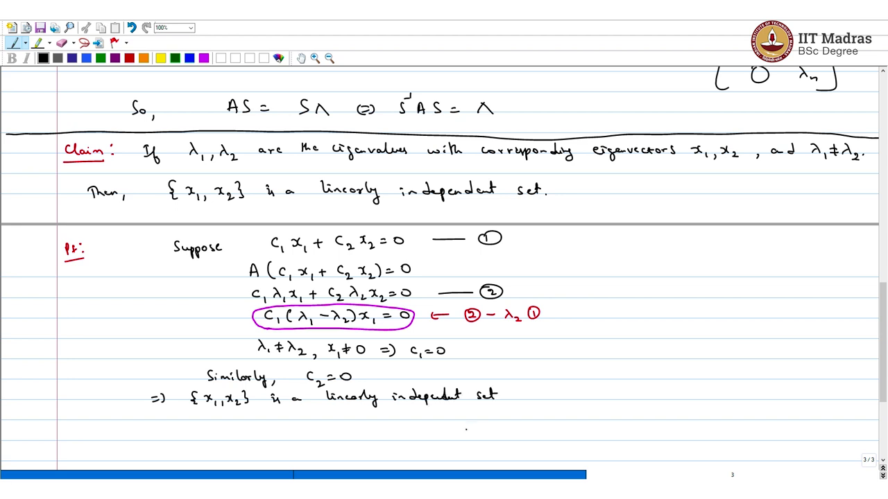
Which is equivalent to say in S⁻¹AS = diagonal matrix. We already showed that S is invertible. So, the point is a matrix is diagonalizable if it has enough independent eigenvectors. Which was simple case special case called this a claim. if λ₁, λ 2 are the eigenvalues with corresponding eigenvectors x₁, x₂ and λ₁ and λ₂ are distinct. So, λ₁ is not equal to λ₂, then x_{1,} x₂ is a linearly independent set.
So, eigenvector belonging to different eigenvalues corresponding to different eigenvalues are linearly independent. That is really the claim. We can show this. So, we will start with the linearly independence requirement. The condition is like suppose some constant times x1 + some constant times x₂ = 0. Let me call this equation 1. If I operate A on both sides, then I get A(c₁x₁+c₂x₂) = 0.
But this is nothing but c₁ times Ax₁ is λ₁ x₁. A x₂ is λ₂ x₂. which means λ₁ x₁₊ λ₂ x₂ =0 so call this equation 2. Which is like saying that c₁ (λ₁ - λ₂) x₁ = 0. How did I get this? This I obtain by taking eqn2 -. λ_{2×} eqn1 So, that is what I did. Now, λ₁ is not equal to λ₂ and x1 is not equal to 0. So, what does that imply? So, in this equation which is above let us say this one in this equation λ₁ - λ₂ is not 0. x₁ is not 0. So, the only way that equation can be 0 is when c₁ is 0. Similarly, c₂ can be argued that c₂ is also 0. And just implies x₁, x₂ is the linearly independent set.
(Refer Slide Time: 11:43)
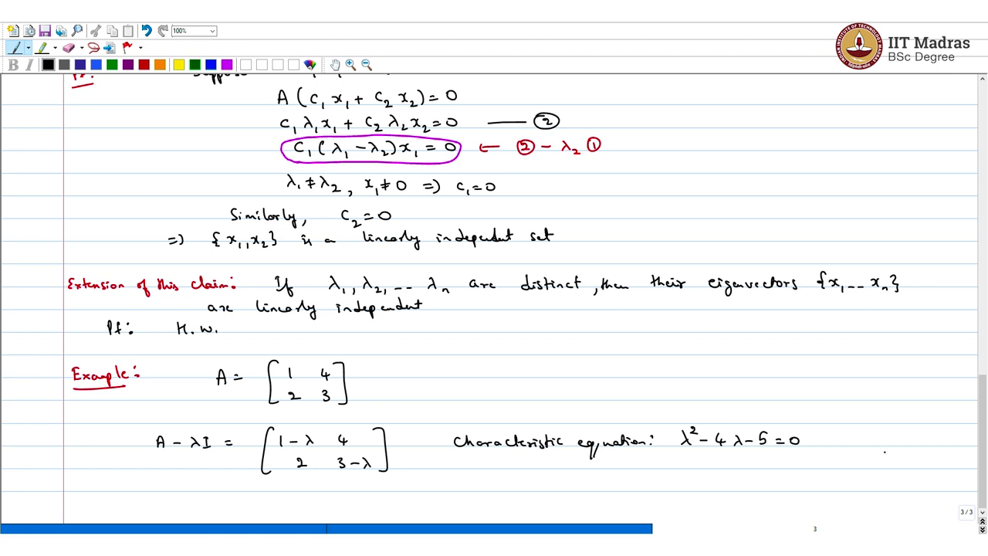
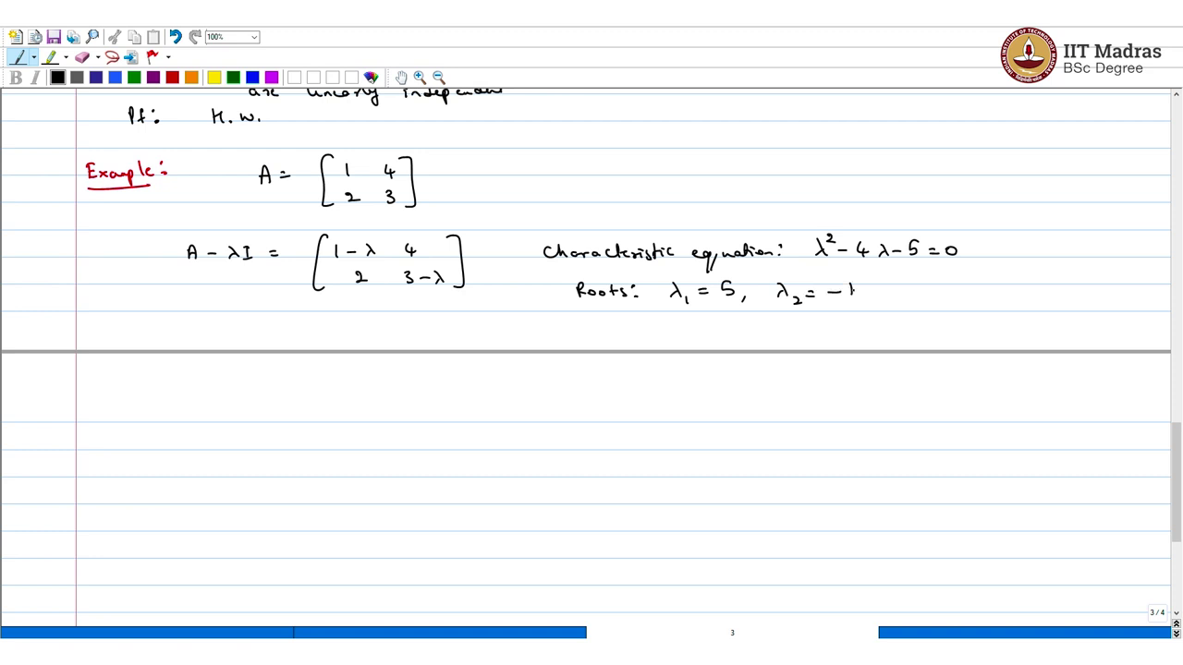
Now extension of this claim which I am not going to prove. But it is going to follow the same arguments. Which is if λ₁ to λ_{n} are distinct. Then their eigenvectors x₁ to xn are linearly independent. I will give you this as homework, proof homework. But use the arguments that have done above and you can argue this. So, we will do an example take this matrix A row $\left[\begin{matrix}1 & 4 \\ 2 & 3\end{matrix}\right]$. So, let us calculate the eigenvalues and eigenvectors of this matrix for some practice.
So, (A – λI) A is nothing but [[1 – λ,4], [2, 3 – λ]]. So, the characteristic equation is so I recommend you pause the video and do this on your own then verify with what I got here.
(Refer Slide Time: 13:49)
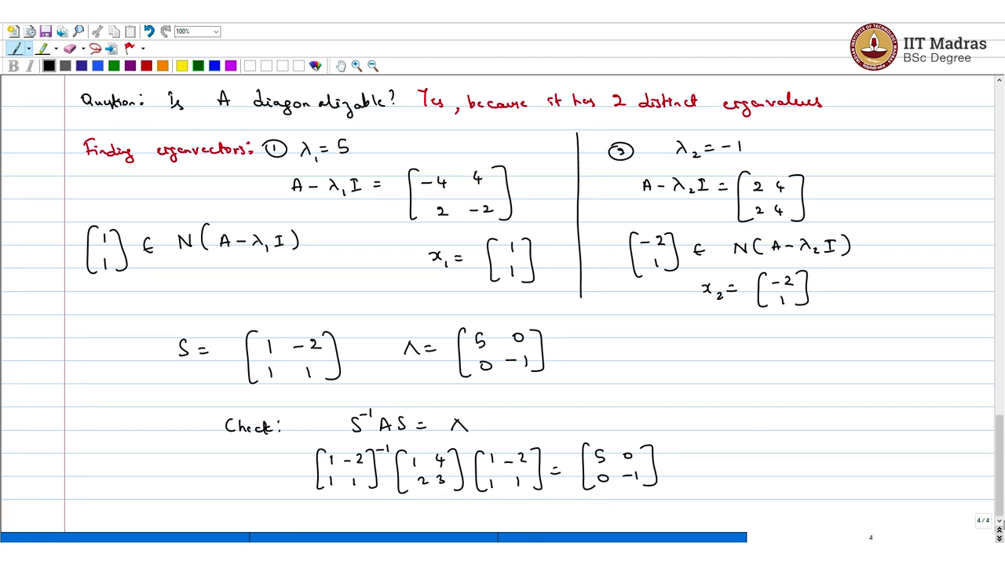
The roots of this equation so roots are let us say λ₁ = 5 λ₂ = - 1. So, now is the question is A diagonalizable? The answer is yes because it has two distinct eigenvalues. It has two distinct eigenvalues. So, the corresponding eigenvector form a linearly independence set and you got enough independent eigenvector to diagonalize the matrix. So, what is pending now, you need to find the eigenvectors.
Finding Eigenvector, so let us take the first one λ = 5. So, the corresponding matrix is you have (A - λ₁ I) it turns out to be 1 - λ is - 4. I have the other two are entry same and 3 - 5 is - 2. Now, what is the null space of this matrix? Null space of (A - λ₁ I). if you look at it if I just add the columns that is enough. So, this belongs and that is the only thing that belongs. So, x₁ is [1, 1] ^{T.}
Though then let us look at a second eigenvalue λ₂ = - 1. In this case, A - λ ₂ I it turns out to be $\left[\begin{matrix}2 & 4 \\ 2 & 4\end{matrix}\right]$ Now, so how do I make some of column 0, I can take - 2 times the first column and 1 times the second column. So, [- 2 ,1] this is one possibility I mean [2, - 1] you also work belongs to the null space of A - λ₂ I. So, x2 = [- 2, 1] ^{T.} That is about it.
Now, you can form the matrix all you have to do is the matrix S is going to be stacked the eigenvector - 2, 1. And the diagonal matrix is going to be the eigenvalues which is 5, - 1 just be careful when you add these eigenvectors you have to add the eigenvalues also in the correct order. And then you can check this is something that you can easily check S⁻¹AS = λ this is something you can check.
Which is [[1, – 2], [1,1]] ⁻¹ × [[1 ,4], [ 2, 3]] × [[1,- 2],[ 1,1]] = [[5, 0],[ 0 -, 1]]. So, that is an example now please try to solve some more problems on your own diagonalize matrices take even a slightly higher dimension say 3 × 3 and solve these problems.
(Refer Slide Time: 18:09)
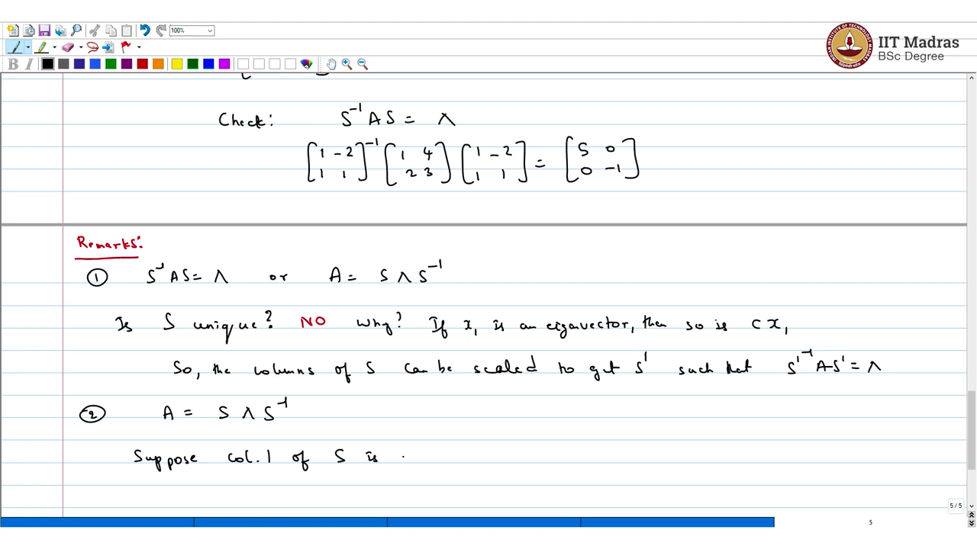
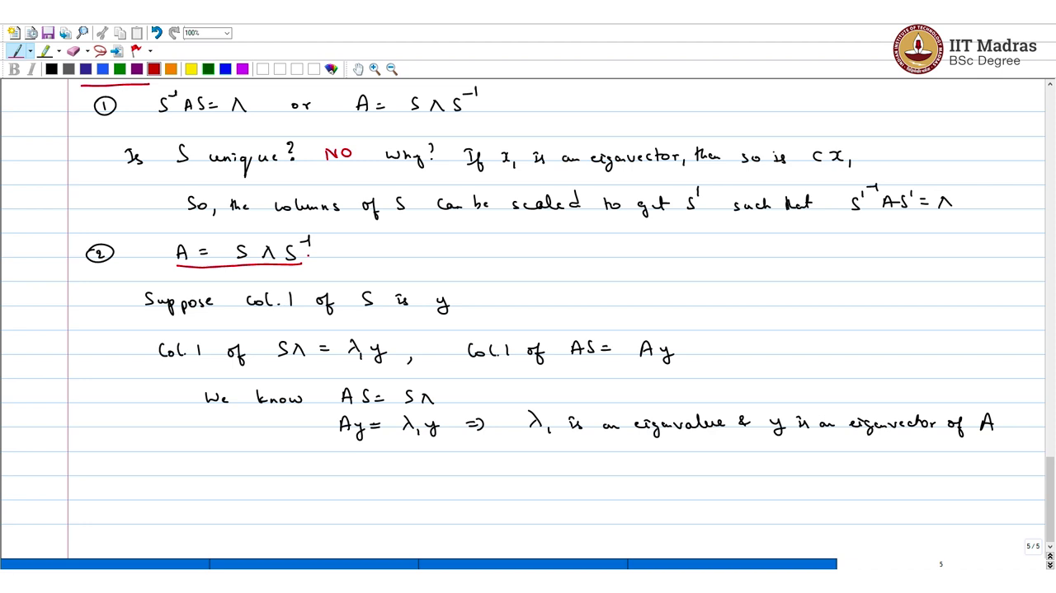
We will continue with a few remarks or observations about this.
Remark number 1 S⁻¹AS = λ or A =S λ S⁻¹ and the same. The question is S unique for a given matrix here. Think about this. The answer is no. Why? If x₁ is an eigenvector, then so is any constant multiple of x₁. So, if you take the previous example instead of taking [1, 1] I could have taken [2, 2] and I would still get a valid S.
So, the columns of S can be scaled to produce to get S prime such that you know S prime inverse AS prime is also a diagonal matrix. The diagonal matrix will not change it is, the diagonal entries are all eigenvalues that will not change but the matrix containing eigenvectors will change. Now, that is something that will make precise in the second remark suppose A can be written like this. And suppose column1 of S is y.
Now, what is column 1 of S λ? Column 1 of S λ is nothing but λ₁ y it just by definition. Now, what is column 1 of AS this is nothing but A pre multiplying the first column Ay. Now, we know AS = λ which is the same as in Ay = λ₁ y implies λ₁ is an eigenvalue and y is an eigenvector of A. So, the point we are trying to make is if A is diagonalizable then the diagonal matrix can only contain the eigenvalues of A.
And matrix AS contains the eigenvectors of A. But matrix S is not unique but there are only one set of eigenvalues for a given matrix. So, the diagonal matrix is going to be the same.
(Refer Slide Time: 22:36)
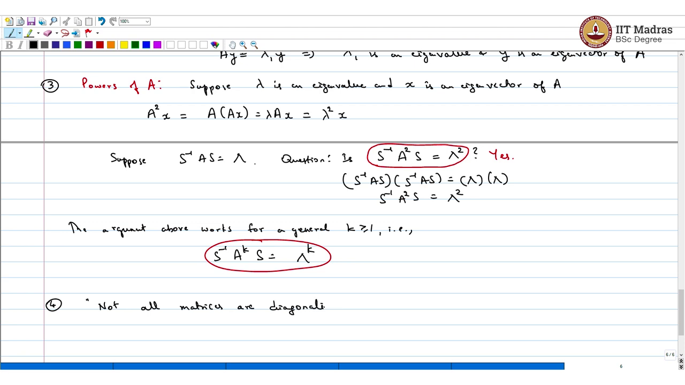
Let us look at another remark which can look at powers of A. So, suppose λ is an eigenvalue and x is an eigenvector of A, then what can we say about A²x? A² x is nothing but A (Ax) but x is an eigenvector. So, it is A of λ x which is same as λ times Ax which is again equal to λ² x. Now, if you suppose S⁻¹AS is diagonal matrix, then the question now is S⁻¹ A² S is that equal to λ square?
I would think about this given whatever I have written above think about this. Which is like saying that can I use the same matrix of eigenvector and diagonalize A square? The answer is simply yes. Why? It is easy to say this. So, if you take (S⁻¹AS) × (S⁻¹AS), what do you get?
This is the same as this into this which is like saying that S⁻¹ A² S = λ^{2.} Now there is nothing special about the square. Argument above works for a general positive integer k1 that is can you infer S⁻¹ A^{k} S is just λ^{k}. Now, the last remark.
(Refer Slide Time: 26:02)
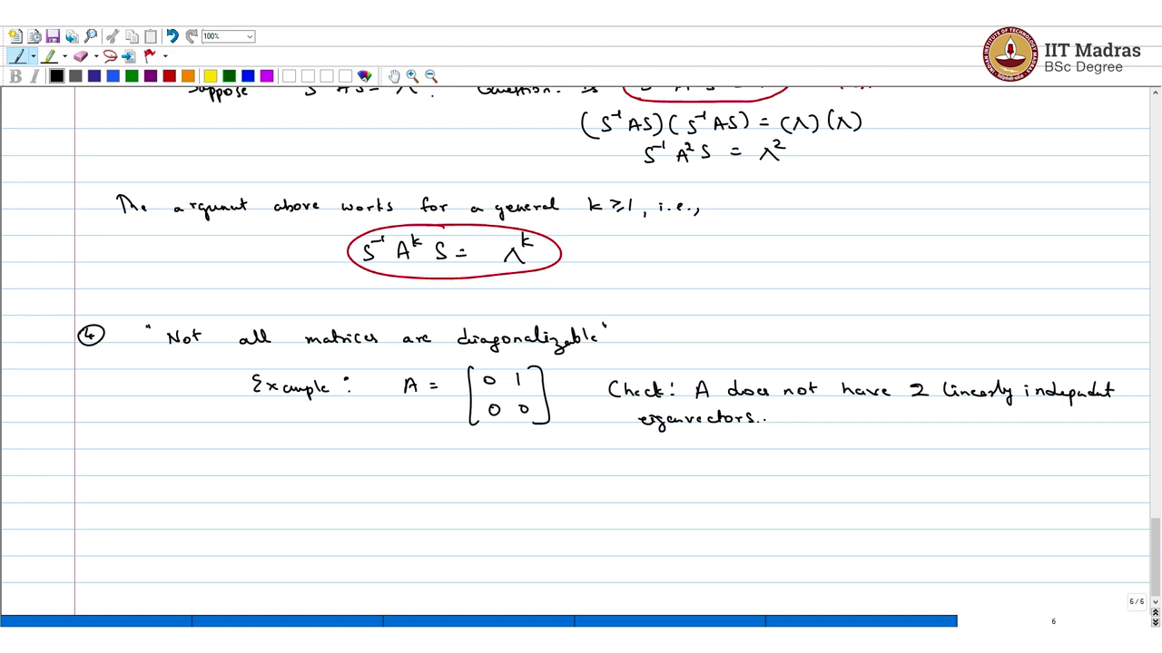
If you want an example take this matrix you can check A does not have to be linearly independent eigenvectors. You can check this easily all you have to do is calculate the eigenvalues which has were easy to calculate. And calculate the corresponding eigenvector and you will get only one eigenvector you only get one eigenvector.
Recap of this lecture before we end. So, what did we learn in this lecture what we understood was that now we understood the concept of diagonalization of a matrix. And for diagonalization of a matrix so what happens is you know there are two matrices that come into play the first matrix is where all the eigenvectors go in and it is going to be invertible.
And the other is a diagonal matrix which contains the eigenvalues along the diagonal for a particular matrix. So, if I get enough matrix is diagonalizable say n ×n matrix we saw that n × n matrix is diagonalizable if I can get any linearly independent eigenvectors otherwise it is not.
Then we looked at two simple examples where for example 2 × 2 matrix where we could get two linearly independent eigenvectors and we could directly calculate the diagonalized form we could write it in we could write down the decomposition of this matrix to show that it is diagonalizable.
And subsequently in the next lecture will be and the following lectures we will try to understand which matrices are diagonalizable and which are not. In fact, the mean theorem that we are heading towards is spectral theorem which shows that any real symmetric matrix is diagonalizable.

